**Doringkruin MTB Trail Park**

**Banking Details:**

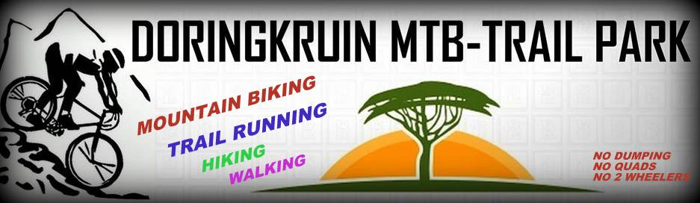**Account Branch Name:** FNB Wilkoppies

**Account Number:** 62487281356

**Financial Institution:** First National Bank

**Branch Code:** 250655

**Account Type:**  Current/ Cheque

**Account Holder Name:**

Romke de Jongh ( MTB Park Director)

Doringkruin MTB Trail Park

*Park Fees 2014:*

*R150 Per single Membership.*

*R200 Per Family Membership. ( Maximum 5)*